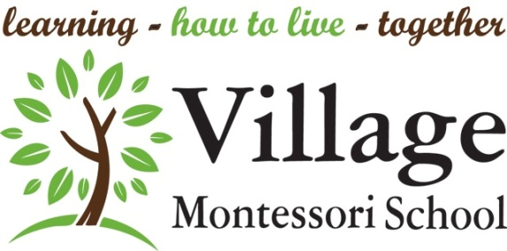
May 2024 – Newsletter

Ms. Andrea – Toddler
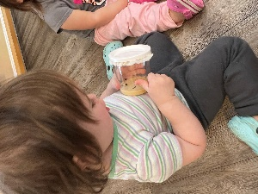
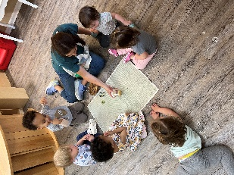
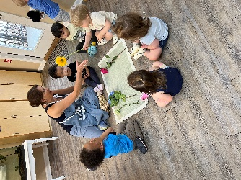
Metamorphosis!
“A profound change in form from one stage to the next in the life history of an organism…’
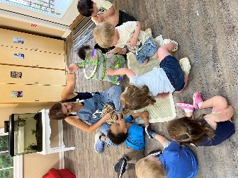
For our last school project, we received a jar full of tiny caterpillars that kept growing until they were not hungry anymore. Now they are in a cocoon. We transitioned the cocoons into a butterfly garden, and we are patiently waiting for the cocoons to hatch into beautiful butterflies. We see the cocoons every day, we read “The Very Hungry Caterpillar”, we talk about flowers and insects and birds. As the 2023-2024 school year culminates, the children have transformed themselves from young toddlers, to independent, problem solving, self-assured young children. Just like the caterpillar, our students are in a process of profound change from one stage of life to the next. Our students have grown and blossomed, and some have flown from our garden and into the next realm of school. During the semester we bid farewell to Sienna, Ezra, Vincent, Will, Wylder, Nara, Aiza followed by Mui and Chloe, as they transitioned from the early toddlerhood stage into young children ready for the next level. During this last semester Skylar, Camille, Macallister and Aenea joined our class who will be our leaders for the next school year in fall with Arthur and Josef. It has been a pleasure to work with all the children and parents and we are excited for the summer and school year ahead!
Thank you, thank you, thank you, for the beautiful flowers, the thoughtful cards, delicious lunch and all the contributions and gifts we have received from you! Have a wonderful summer! With Much appreciation.
Ms. Katie, Ms. Hansa, Ms. Ava, and Ms. Andrea

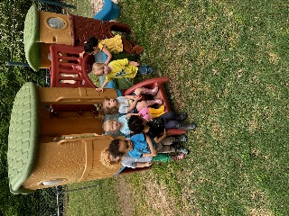
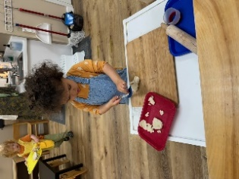

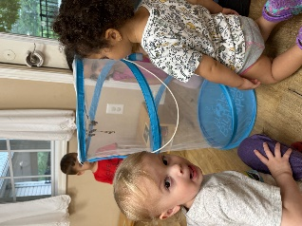
Ms. Danielle – Toddler
This year has gone by so fast; I can’t believe it’s already May. Our classroom is very busy, yet everyone is focused and working hard. We have been having some unpredictable weather, so when is nice we are trying to spend as much time outside as we can. The kids like to sweep the ground with our push brooms and tidy our garden.
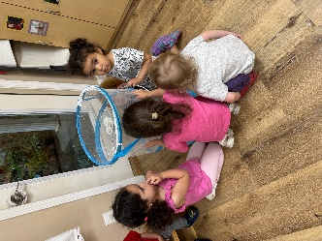
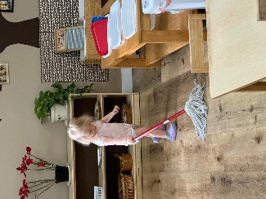
We have around 6-7 caterpillars in our classroom that are growing and becoming cocoons. We have been watching them carefully and follow every step of the transformation to become beautiful butterflies. We are looking forward to seeing them come out of their cocoons and let them fly free in our garden when the time is right!
One of the kids’ favorite times during the day is circle time, we spend time learning grace and courtesy and patience by taking turns. We read, do yoga, dance, sing and rhyme. They get to spend time with each other and socialize, it’s heartwarming to see them enjoying their friend’s company and encouraging them to get involved and be part of the class.
It’s always a pleasure to work with each one of your children. Have a very safe and restful summer!
Ms. Veronica, Ms. Ava, and Ms. Danielle
Ms. Luz – Primary
The end of the school year has brought surprises and changes to our community. As always, children are the best example of resilience and adaptability. Ms. Laura shared her observations about the children's sense of community and how they continue to help and care for one another. We are grateful that Ms. Laura has done an excellent job with the children in the last weeks.
We also want to thank you for entrusting us with your child's learning journey. Seeing each child's progress through these two years has been a joy and a privilege. Progress looks different for each individual. Exposing children to different experiences is like planting a seed; while we expect the seed to become a plant, we trust the roots grow unnoticed underground. The fruit and the flowers will show in their own time.
As we say goodbye to those moving on to Elementary and those starting new journeys at other schools, we wish them all the best. We will miss them dearly, but we know their example will continue to guide the younger children returning next year. We are excited to welcome them back!
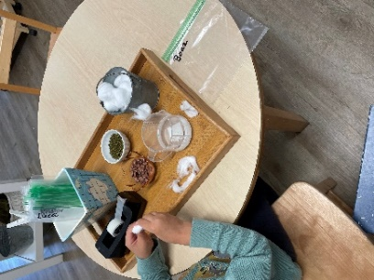
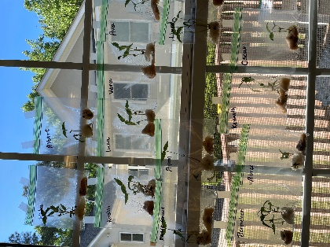
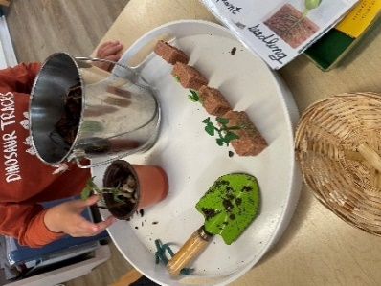
Finally, thank you for partnering with us during this school year. We hope you and your families have a safe and fun summer!
Kind regards,
(Ms. Luz) Ms. Laura, Ms. Ekta & Ms. Beth
Note from Ms. Luz: Thank you for your notes, cards, and emails. I can't wait to return to the environment next year and be with the children again!

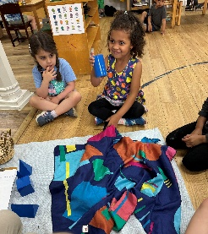
Ms. Asma – Primary
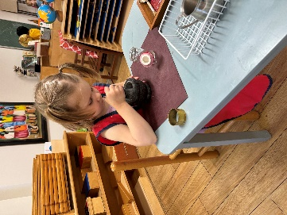
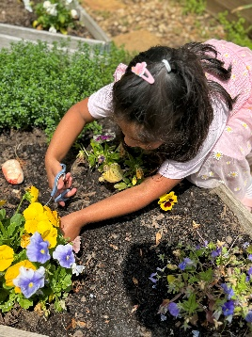
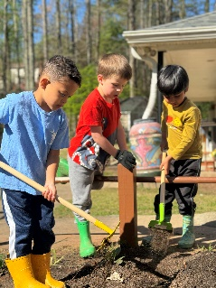
It's hard to believe the year is almost over. As we all know and see, children grow each day. They learn and keep growing, no matter what day or month of the year it is, as their caregivers it is pivotal to remember each child is unique and is moving on his/her own unique journey of learning and we must ensure that we create and provide the space and environment they need to develop independently.
"It is not always imperative to see big things, but it is of paramount importance to see the beginnings of things. At their origins there are little glimmers that can be recognized as soon as something new is developing" - Dr, Maria Montessori, Education and Peace.
Last month, we celebrated Earth Day by reading books and creating artwork on saving our planet Earth. We started the month of May with art projects for Mother’s Day. All the children picked up flowers, pressed them and then made beautiful cups as gifts for their mothers. The afternoon children are preparing for one of their favorite events, the Spring tea. It is a special event in which the children invite their guests and prepare the tea and food to serve them. A wonderful opportunity for a child and an adult to connect gracefully in their environment!
And last but not least, I would like to thank all the parents for investing their time and resources in volunteering for their children and their community. A big thank you to our room parent Ms. Katie for organizing and executing all the plans throughout the year. I look forward to working with my families next year!!
Important dates:
Last day of the school: May 23; Half day dismissal is 11:45 am
End of the year picnic: May 23rd, 12-2. More information to follow.
Ms. Asma, Ms. Gini, Ms. Violet

Ms. Siobhan – Lower Elementary
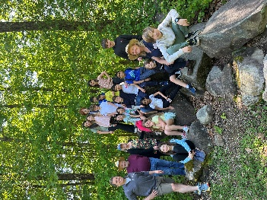
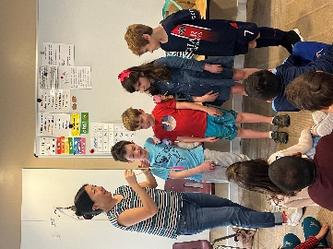
The children enjoyed a wonderful presentation on dental hygiene courtesy of Eunis Choi, Beanie’s and Joonhee’s mom. She taught us all about “sugar bugs'' that get stuck in our teeth and the importance of daily brushing and flossing. Thank you Eunis! We have enjoyed watching our caterpillars grow and form their chrysalises, and we are now eagerly awaiting the emergence of our butterflies! Third year students had a spring sleep-away trip to Charlie Elliott Wildlife Center where they enjoyed a two-night adventure filled with lots of fun, educational experiences. They learned a lot, shared a lot, and grew a lot! We received many compliments about behavior, participation, level of knowledge and interest, and manners. The kitchen staff mentioned that our children did a better job than any other group (including adult groups) at the serving area. They left minimal mess, especially on taco night! The education director mentioned that we were their best group and discussed some of the positive attributes she saw particular to our Montessori group.
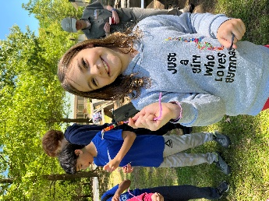
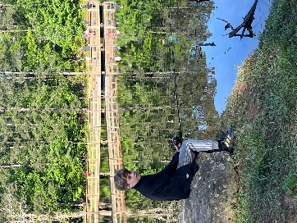
Teacher Appreciation Week was wonderful - from the coffee and tea, the treats, the beautiful flowers, yummy lunch, and the very generous gift and sentiments from the class. We are so appreciative! Everyone knows teaching is not an easy job and not the most lucrative, but we are so fortunate to witness the growth of these amazing little people- to share in their struggles and successes, their sadness and joy, to witness their passion and enthusiasm. We are so richly blessed! Be on the lookout for communication coming home about our summer birthday celebration (pizza is involved!), field day, crazy hair day, and other end of year information.
We are always sad to say goodbye to our third years as they begin their next chapter. We wish them every success at the next level and wish you all a wonderful summer!

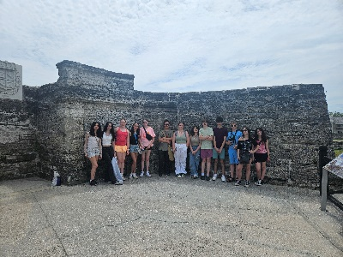
Mrs. Hill & Ms. Suzanne – Middle School
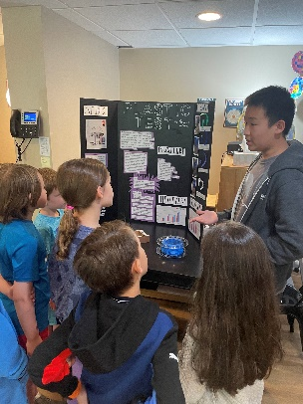
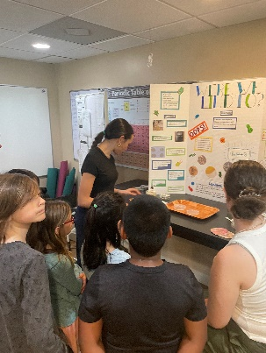
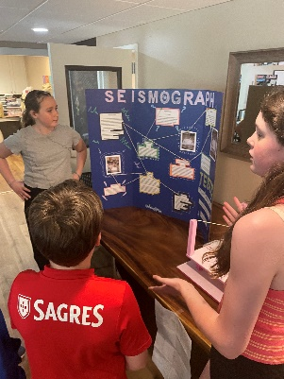
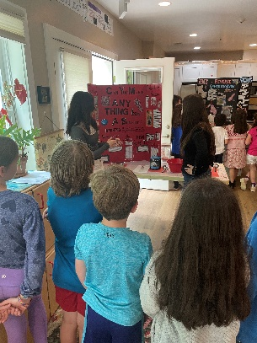
As we end the year, the Middle School students are looking forward to the summer after completing an amazingly busy two months. April was filled by completing our science experiments, helping on the horse farm, practicing math, Spanish, art and perfecting our original song in music! In May we took a history field trip to St. Augustine, Florida. We explored the Fountain of Youth, the Castillo de Marco Fort, walked on the first cobblestone streets in America, visited the Old Jail, saw every type of crocodile and alligator you could imagine at Alligator Farm. We spent the afternoons on the beach collecting shells and swimming, then we went crab hunting in the evenings. We completed our final production and exchange event with our Mother’s and Special Person Day Flash sale. Thank you to all that purchased cards and gifts! We still have a dance planned, field day to host for elementary and our final P.A.W.S. free adoption day! Whew. Finally, graduation for our graduating 8th and 9th students on the last day of school. This year has flown by with lots of hard work, creative studies in science, language, math, and art, hosting complex production and exchange events, performing in theater, and creating music together. The friendships formed are deep and special. We wish our students the best in their futures outside of VMS. You are ready. We will all miss you. For the rising 7th and 8th years, we look forward to next year and the fun, creative, and hard work ahead!
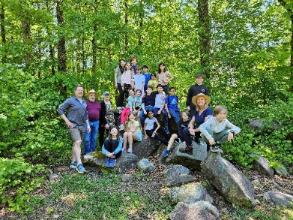
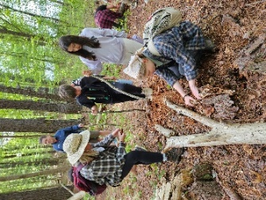
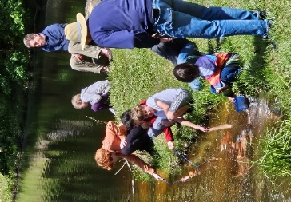
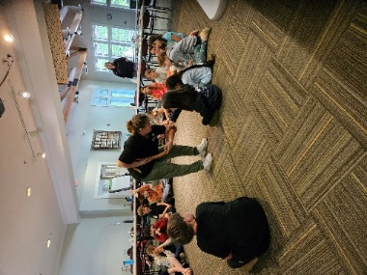
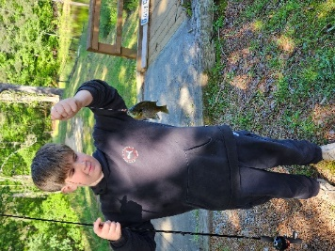
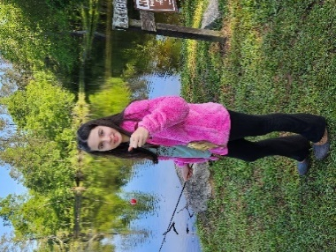
Mrs. Emmie – Upper Elementary

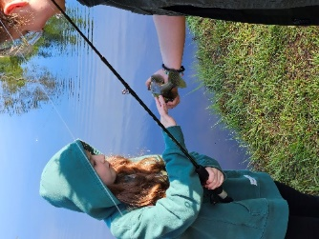
Our class went to Charlie Elliott, Monday through Wednesday, April 22-24. We had a wonderful time. The weather was perfect, and the children really enjoyed being with each other and having some new experiences. We enjoyed classes in geology, water ecology, exploring the woods and fishing. I have to say that the favorite class of everyone was fishing. Just about everyone caught at least one fish. Two children even managed to catch one fish on two baits. The same fish swallowed both of their bait. The environment there was beautiful. The children saw turtles, an armadillo, large and small birds, snakes, some large wolf spiders, and many other small animals. They got up close with a box turtle and a corn snake. They visited the museum on site and learned about conservation and all about Charlie Elliott himself. They participated in a scavenger hunt in the museum, and they really enjoyed it. The staff there commented on how nice all the children were and how well they participated. The staff there were very patient with the children and carefully demonstrated how to bait a hook. They first used a gummy worm to show how to hook the worm and then gave them a live worm to hook. The staff spent time explaining that the bait was food for the fish we were trying to catch and that was the way the food web worked. Most children were able to finally hook their worm. One child used that worm until there was nothing, but a sliver of skin left on the hook. There is so much that the children take away from these overnight trips. They learn that they can take care of themselves and their own things. They develop stronger relationships with their peers, and they create lasting memories of the lessons learned because they physically experienced their environment. This was proven by two children who pointed out where we encountered an inground bees nest the last time we went to Charlie Elliott. Many other memories surfaced as well. This is the reason Montessori materials work so well. It is an experience, not memorization. What a wonderful trip!

Ms. Lola – Primary

Dear Families,
Spring semester is such a wonderful time filled with budding plants in the garden and soaking up the sunshine. This month, the children have been carefully watching our caterpillars turn into chrysalises. Hopefully, in the next few days, they will become butterflies! We have been talking about the life cycle of the butterfly quite a bit. As we've been discussing all of the stages, it reminded me of the three-year cycle that the children undergo. First, they begin soaking up as much knowledge as they can and spontaneously move from one material to the next. Then, they begin to transform into workers that have knowledge to apply to new works. And finally, they are able to consolidate all their skills and knowledge. By which point, they are able to fly away to Elementary.
Last week, we had an enjoyable Spring Tea. Thank you to all the parents that participated in making the event a success! The children were so happy to host their guests. The Spring Tea is one of my favorite events as it really showcases all the skills the children have mastered during their time in Primary.
It is crazy to think that the school year is almost over! I have enjoyed partnering and getting to know each of our families. I wish you all a joyous summer!
Warmly,
Ms. Lola, Ms. Joni, and Ms. Poonam

